Ansible

Ansible configuration managemetn tool

Infrastracture as a code => domain specified language

Ansible push mechanism

Ansible enterprices version name ansible tower

Ansible is maintained by Redhat

It is writen in yaml format

In ansible we have master and agents

Ansible is agentless configuration

Ansible roles

1. Defaults: - data about the role/application default variables
2. Files: - put the static files files will then be copies on remote machine
3. Handler: - Tasks which are based on some triggers
4. Meta: - information about playbook information role like author
5. Tasks: -core logic
6. Template: - Dynamic variables template language, jinja2
7. Vars: - both vars and defaults stores variables variables stored under var has got higher priority

Ansible lab

Take two instances one instance for master and other one for agent in first picture I was connected agent to the git bash

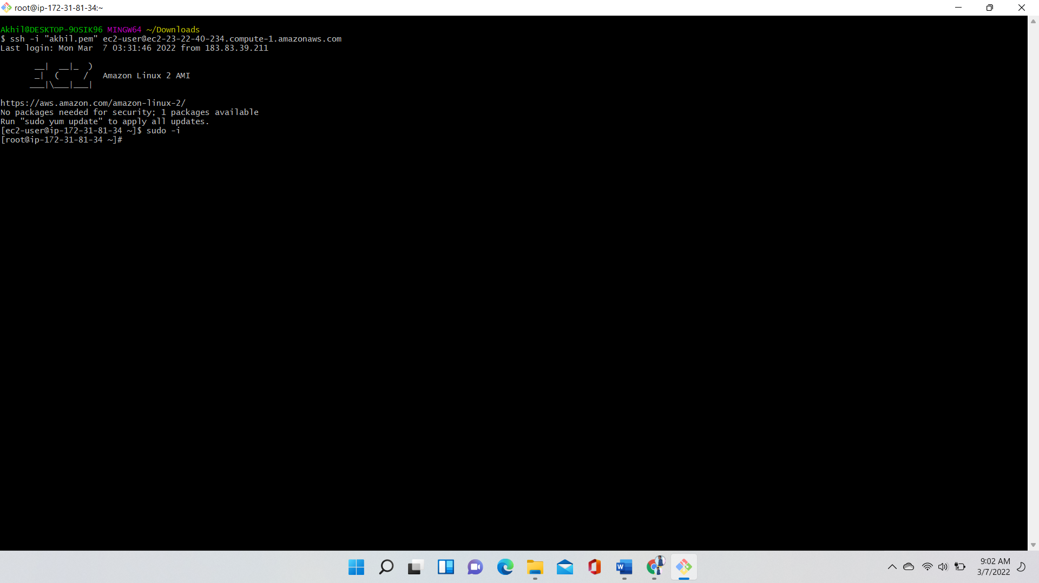

In second picture I am connect master to the git bash (set hostname (hostname master))

In master machine I was installed ansible using command (yum install ansible)

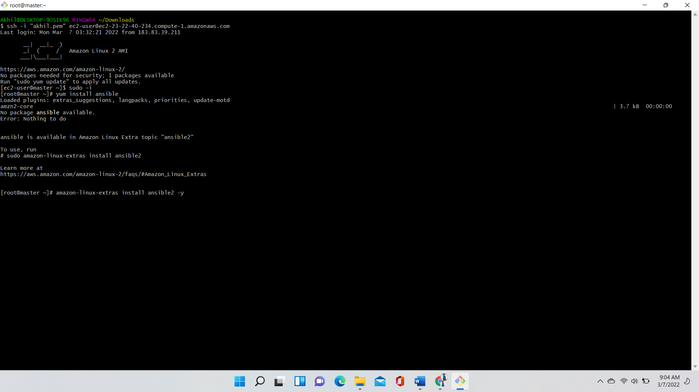

After installing the ansible in master check the ansible verrsion using command (ansible --version)

In master Generate ssh key using the command (ssh-keygen -t rsa) copy the public key

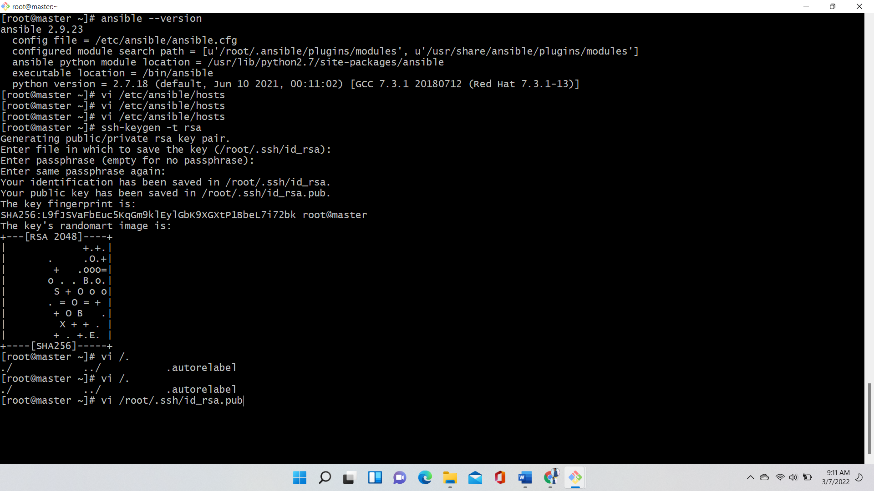

In agent machine go to .ssh/authorized keys and paste the public key which is copied in master machine

In agent go to (vi /etc/hosts) give master private ip address and master (ip master)

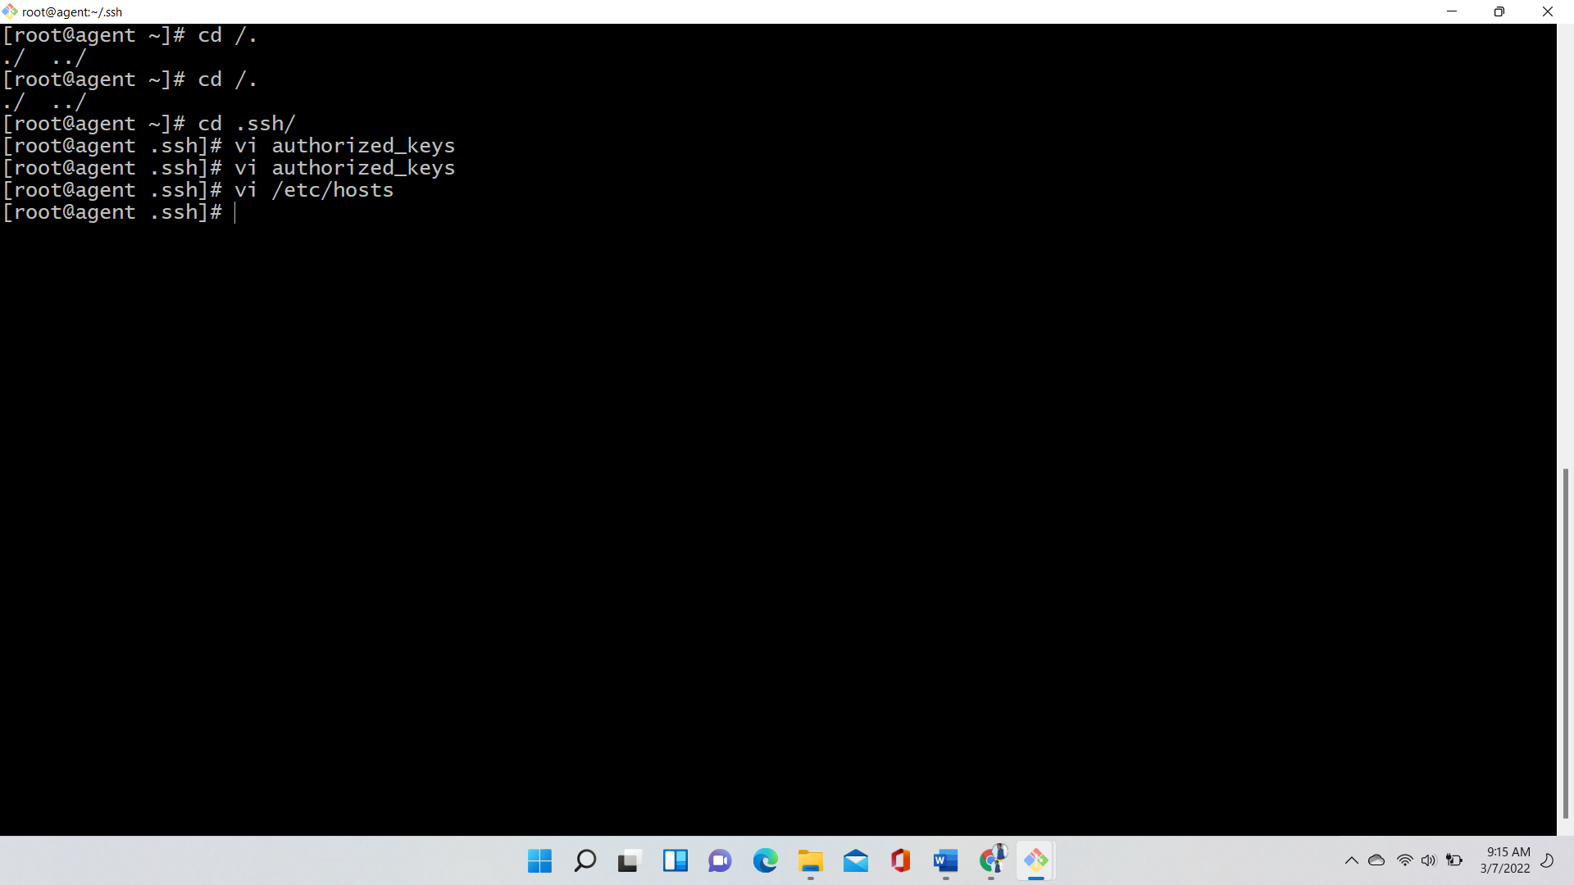

In master go to (vi /etc/hosts) provide agent private ip address and agent name

After that go to inventory file (vi /etc/ansible/hosts) here mention your agent name

Check ansible agent -m ping  
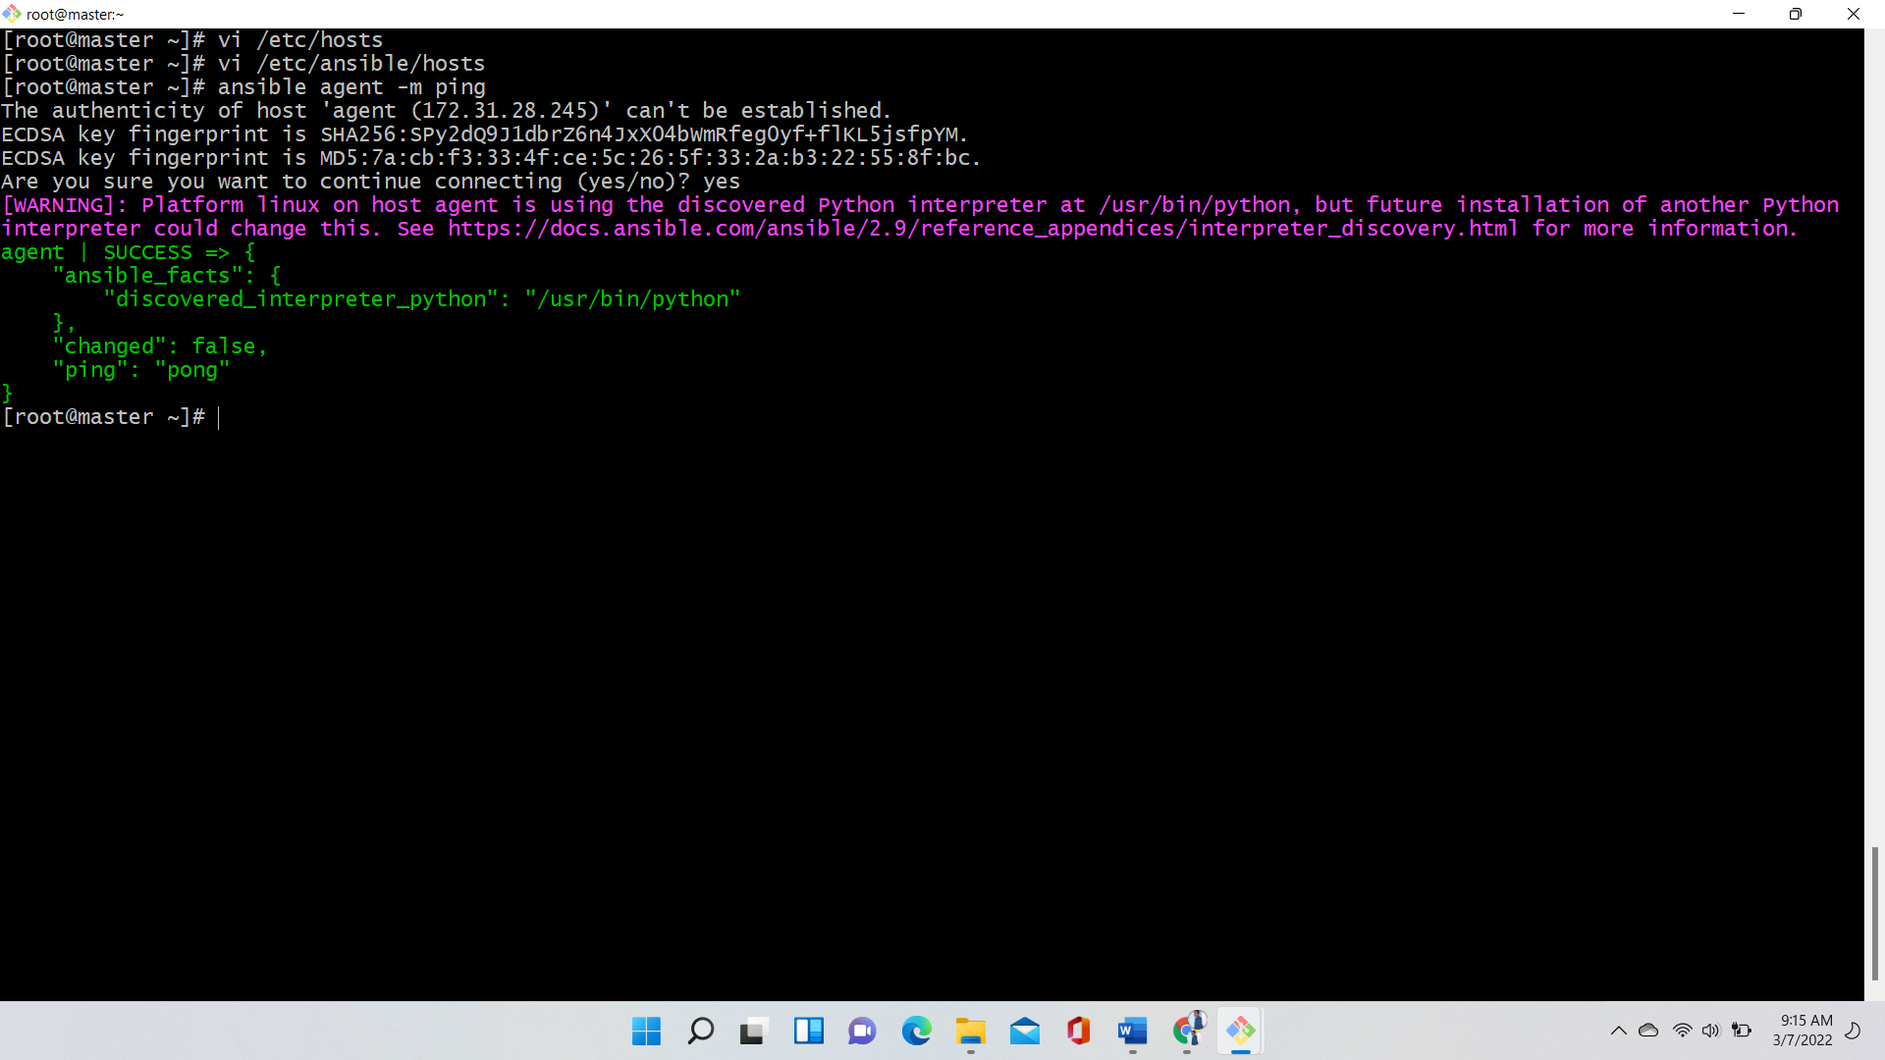

Here I am created a file In master machine and copying that file into agent using below command

Ansible agent -m copy -a ‘src=/root/sample.txt dest=/root’

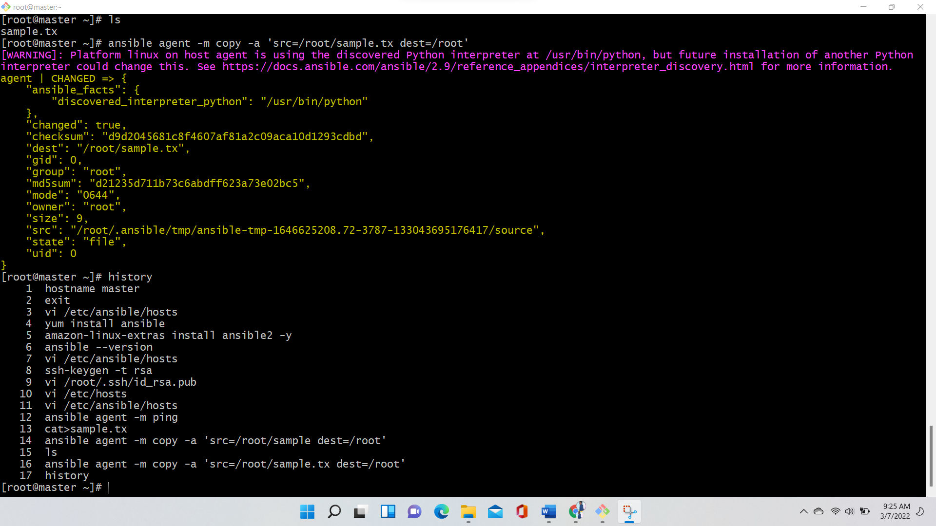

History is the command to check the history

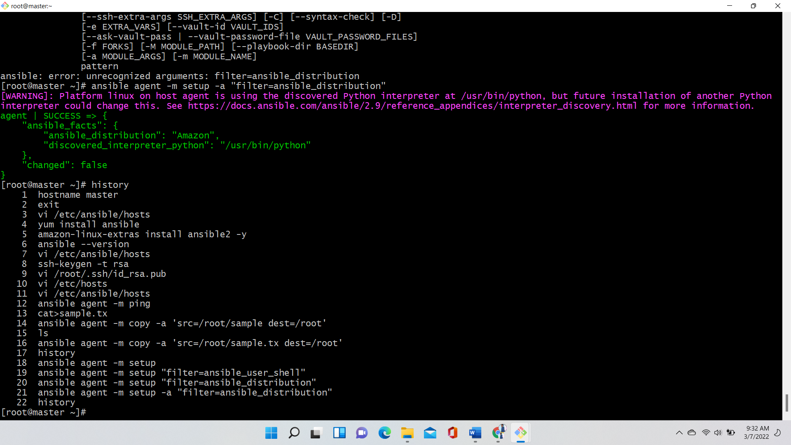

Present I am in master now I am logging into agent from master using below command

Ssh root@agent

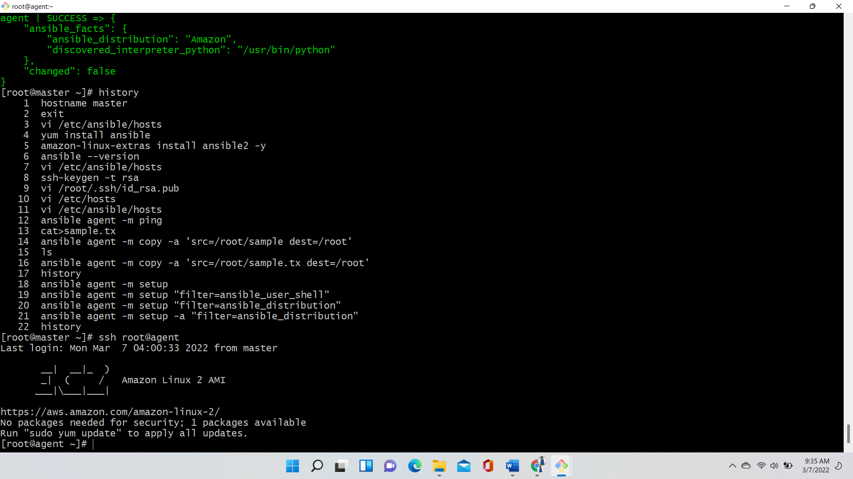

To check disk space of agent (ansible agent -m shell -a ‘df -h’)

To check memory space of agent use command (ansible agent -m shell -a ‘free -a’)

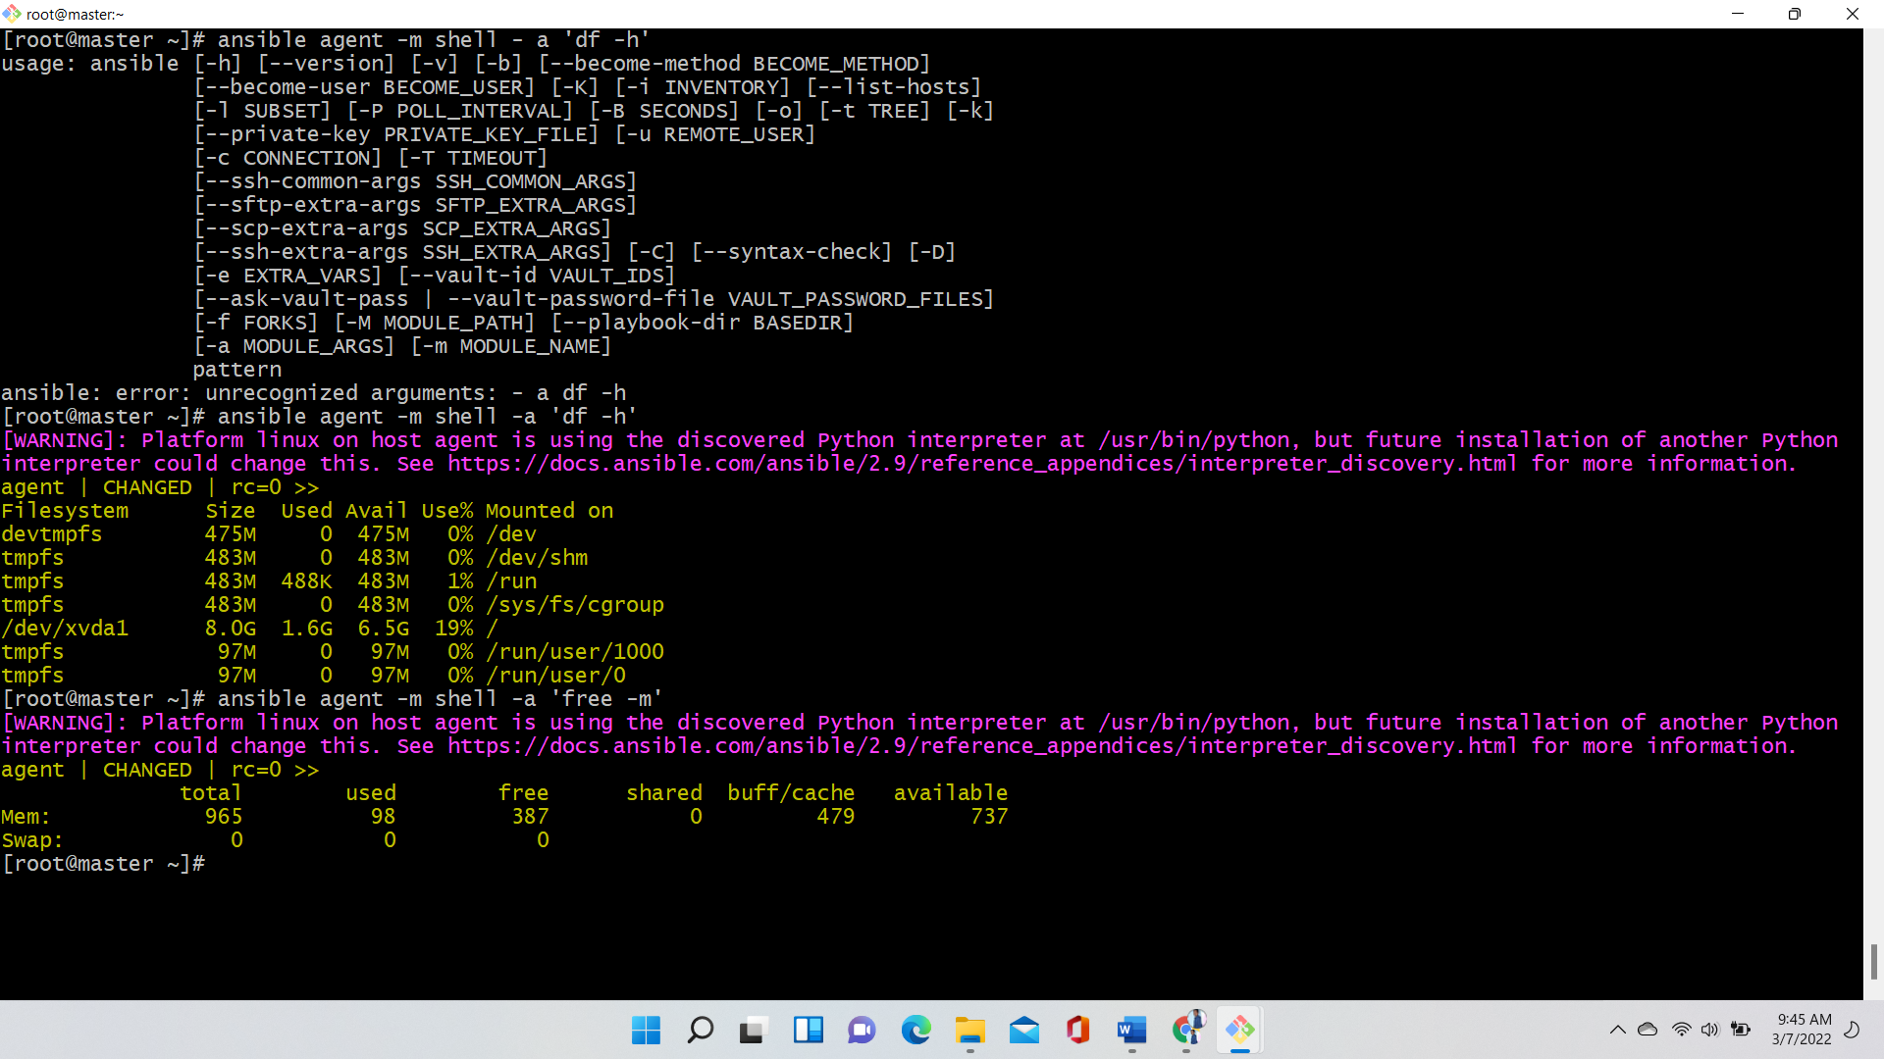

Create a file (ansible agent -m file -a ‘path=/root/123.txt state=touch state=dirctory’) 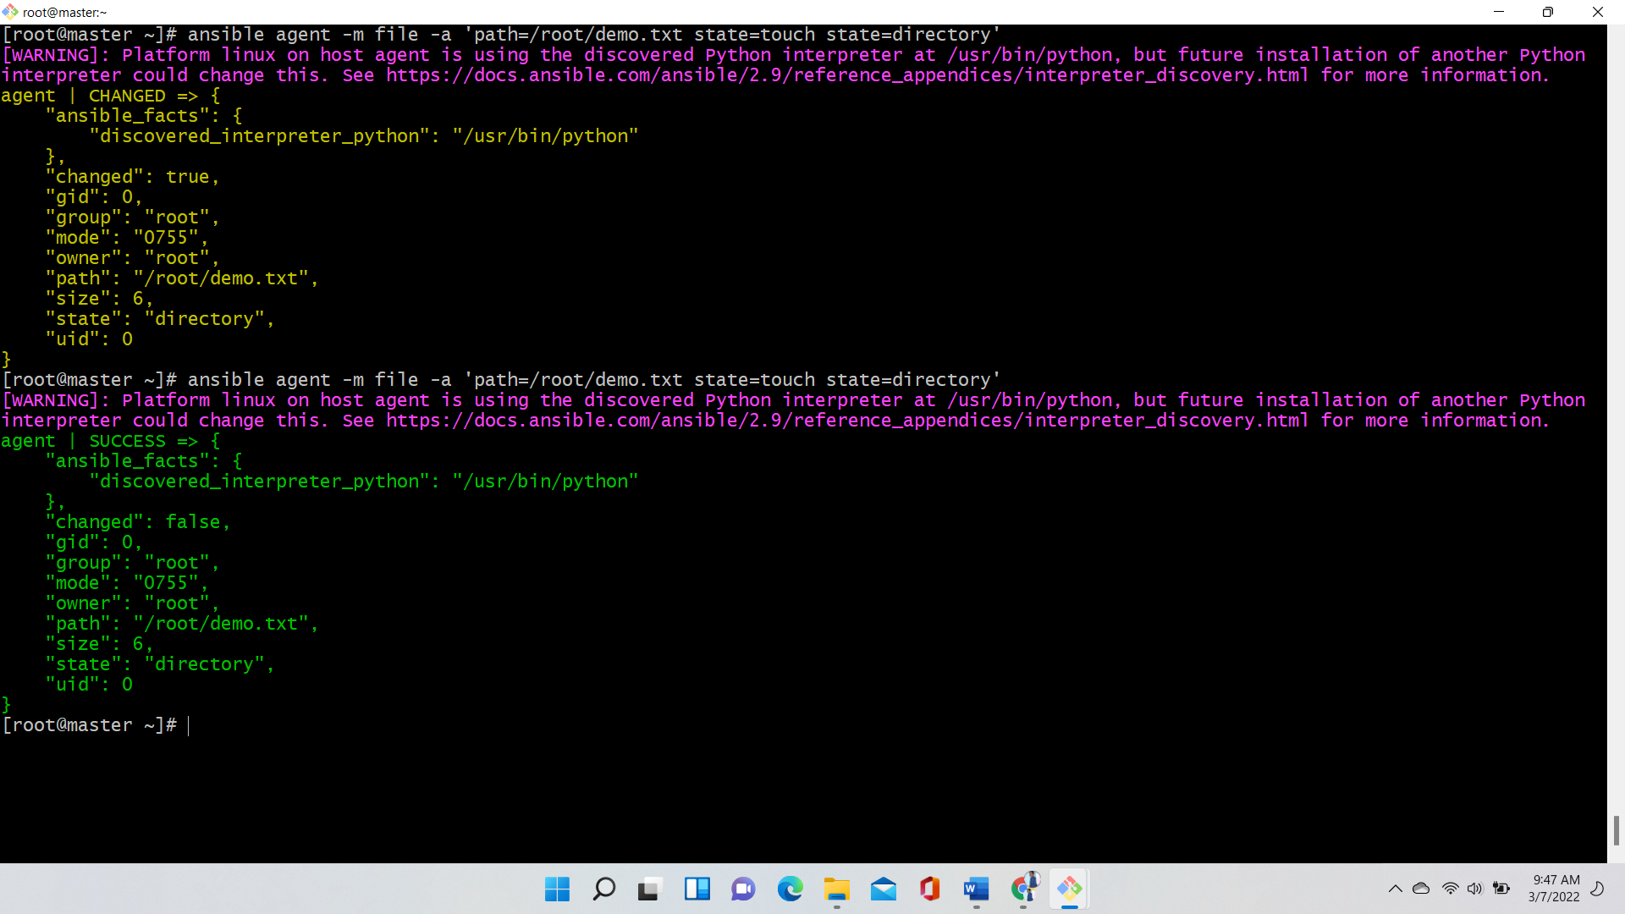

Create a playboock with secure password

Ansible-vault create web.yml –ask-vault-pass

To encrypt data/playbook

Ansible-vault encypt web.yml

To decrypt data/playbook

Ansible-vault decrypt web.yml

If you want to edit the encypted playbook

Ansible-vault edit webserver.yml

